

GW2R Asset Management, LLC
Frisco, Texas, USA

Asset Management Audit Report
Verandas at Bear Creek
January 2026

Audit Top Sheet

Report Section | Audit Findings | Actionable Items | Reference | Deadline
- Operational Report AnalysisT | - For the month of December, the overall occupancy rate remains at 88.75% indicating a downward trend.  - Vacancy, on the other hand, has also remained at 18 compared to the previous month, including the down units indicating upward trend.  - For the month of December 2025, the number of move ins is lower than to the number of the move outs.  - One non-revenue generating unit is used as a Model and reserved exclusively for leasing demonstrations and property showings.A possible loss to income of $890 per month.  - Current rent levels appropriately reflect prevailing market conditions and are effective in maintaining occupancy. Given seasonal demand dynamics, maintaining existing pricing through the winter months is advisable, with the potential to implement incremental rent growth in late Q1 or early Q2 as leasing activity begins to recover.  - 13 units have been unoccupied for more than 15 days. Unit 214 (working on repairs, needs new carpet/Cabinet kitchen ) has been unoccupied for more than 670 days and counting. Based on available units historical report. | Strengthen leasing efforts through targeted marketing, accelerate the lease-up of vacant units, and implement proactive resident retention initiatives. Regularly track performance against occupancy goals to ensure progress and address seasonal turnover fluctuations more effectively
- CAPEX Report Analysis | - The property has the following renovations/upgrades for interior activities for the month of December as of January 20.  - 18 units had partial renovation, mostly resurfacing and painting. | Implement a standardized process requiring unit-level tagging for all CAPEX items at the time of purchase or installation. Ensure vendors and onsite staff document asset assignments in real time to maintain transparency and support future audits.
- Monthly Financial Analysis | - In December, net rental income continued to decrease to 139,451.47 due to higher write off uncollectible amounts to 7,370.90.  - Other income has also slightly increased to 23,519 this month as we have more income collected for utilities-water.  - Due to lower rental, the total revenue decreased by $2,591.16 compared to the previous month, showing a decreasing trend. | Establish more detailed expense tracking and implement controls for variable categories such as contract services, office supplies, and bank/credit fees. Regularly review monthly variances with the onsite team to ensure each increase is necessary and justified. Consider setting category-specific budgets to manage discretionary spending more proactively.

- OPERATIONAL REPORT ANALYSIS

A.​​1 Occupancy Analysis:

- For the month of January, the overall occupancy rate decreased to 87.5% indicating a downward trend.
- Vacancy, on the other hand, has also increased at 20 compared to the previous month, including the down units indicating upward trend.
- For the month of January 2026, the number of move ins is equal to the number of the move outs.
- No move out reason report in the system.
- Physical occupancy and pre-leased occupancy have decreasing trends.
- 6 vacant units and 1 occupied unit are pre-leased this month. All pre-leased units are ready for occupancy.
- The majority of vacant units need make-ready and some repairs.
- Only 2 units are ready for occupancy.
- One non-revenue generating unit is used as a Model and reserved exclusively for leasing demonstrations and property showings.A possible loss to income of $890 per month.
- The property has 6 given notices for occupied units.

APPENDIX 1:

Verandas
OCCUPANCY ANALYSIS | January | Dec | Nov | Oct | Sept | Aug
Total units | 160 | 160 | 160 | 160 | 160 | 160
Physical Occupancy | 87.5% | 88.75% | 88.75% | 90% | 91.87% | 91.25%
Vacancy | 20 | 18 | 18 | 16 | 13 | 14
Pre-leased Occupancy | 87.5% | 86.25% | 90% | 89.38% | 92.5% | 98%
Move In | 4 | 2 | 4 | 5 | 8 | 5
Move out | 4 | 6 | 2 | 6 | 7 | 7

APPENDIX 2:

A.2 Rental Analysis:

- The property has a loss to lease of $26,412 for the month of January.
- The non revenue unit(801) that is used as "Model" is included in the market rent amount.
- Actual rent amount only includes occupied units

APPENDIX 3

RENTAL ANALYSIS | Jan  2026 | Dec  2025 | Nov  2025
Market Rent | $174,390 | $174,390 | $174,390
Actual Rent | 147,977.97 | 150,240.87 | 150,518.00
Loss to Lease | $26,412 | $24,149 | $23,872

Appendix 4

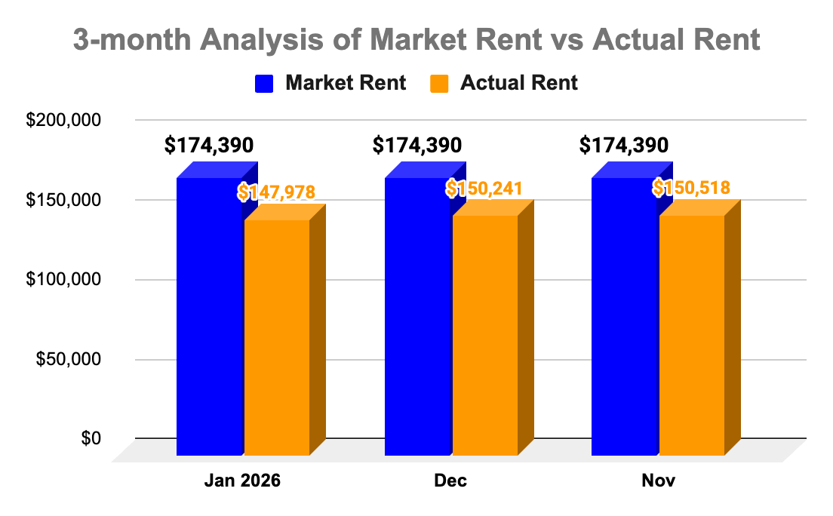

A.3 Rental Comparison Analysis:

Verandas is 87% occupied, reflecting a minor seasonal softening consistent with winter leasing trends. Despite reduced traffic typical for this time of year, the property remains well-positioned relative to comparable assets.

- 1BR: $995 ($1.54/SF)
  - Market avg: $989 ($1.57/SF) — in line with market, offering a balanced value proposition for renters seeking efficient layouts.

- 2BR: $1,135 ($1.31/SF)
  - Market avg: $1,107 ($1.33/SF) — modestly below market while providing larger-than-average floorplans, supporting competitive absorption.

Current rent levels appropriately reflect prevailing market conditions and are effective in maintaining occupancy. Given seasonal demand dynamics, maintaining existing pricing through the winter months is advisable, with the potential to implement incremental rent growth in late Q1 or early Q2 as leasing activity begins to recover.

APPENDIX 5
Property Name | Unit Type | Sq. Ft | Rent | Rent per Sqft
ONE BED/ONE BATH
Verandas | 1B/1B | 645 | $995.00 | $1.54
Towne Lake | 1B/1B | 584 | $966.00 | $1.65
Towne Lake | 1B/1B | 756 | $1,010.00 | $1.34
BC Crossings | 1B/1B | 592 | $1,044.00 | $1.76
BC Crossings | 1B/1B | 703 | $1,068.00 | $1.52
Harper's Mill | 1B/1B | 501 | $837.00 | $1.67
Harper's Mill | 1B/1B | 700 | $942.00 | $1.35
Madison @BC | 1B/1B | 450 | $956.00 | $2.12
Madison @BC | 1B/1B | 659 | $1,079.00 | $1.64
TWO BED/TWO BATH
Verandas | 2B/2B | 864 | $1,135.00 | $1.31
Towne Lake | 2B/1B | 855 | $1,206.00 | $1.41
BC Crossings | 2B/1B | 761 | $1,045.00 | $1.37
Harper's Mill | 2B/1B | 854 | $1,042.00 | $1.22

A.4 Lease Analysis:

- This month, the property has 7 expiring leases with 100% renewal percentage or 7 units (based on Lease expiration report)
- All renewals were renewed for 12 month terms and were renewed at and above the market rent.
- Expiring leases will have a fluctuating trend in the next 30-60 days which we should still be prepared for.
- 14 units have been unoccupied for more than 15 days. Unit 214 (working on repairs, needs new carpet/Cabinet kitchen ) has been unoccupied for more than 701 days and counting. Based on available units historical report.

Lease Analysis | January | December | November
Expiration | 7 | 10 | 6
Renewal | 7 | 10 | 6
Expected in next (0-30 days) | 14 | 6 | 12
Expected next (0-60 days) | 8 | 13 | 6

A.5 Service Request/ Work Order Analysis:

- In January, a total of 49 work orders were submitted for Verandas, with most related to bathroom leaks, plumbing and appliances issues.
- Pending work orders have been unattended for more than 72 hours.
- Most of the pending work orders are about the broken appliances.

Appendix 6:
Work Order Analysis | January |  | December  (Updated) |  | November  (Updated)
 | Completed | Pending | Completed | Pending | Completed | Pending
Service Request | 45 | 4 | 60 | 5 | 34 | 17
TOTAL | 49 |  | 69 |  | 51

A.6 Prospect Analysis:

- The property leads/prospect increase this month to 28 new contacts compared to the previous month showing an upward trend however we still don't have enough leads to cover all vacancies.
- For this lead 18 walkins/visits.
- Drive by is the primary source of prospects with 43% or 12 prospects.
- This month, we received 3 submitted applications, with 3 denied and cancelled leases and 2 net approved signed leases (Box Score).
- The most common interest from new prospects is the one bedroom apartment unit.

Prospect Analysis | January | December | November
Leads/Prospect | 28 | 19 | 27
Status
Submitted/Applied | 4 | 3 | 5
Lost/ Lost & Rejected | 3 | 0 | 0
Lease Signed | 5 | 2 | 3

- CAPEX ANALYSIS REPORT:

1 CAPEX Interior Activities:
- The property has the following renovations/upgrades for interior activities for the month of January as of February 25.
  - 7 units have partial renovation mostly full painting

Renovations | Amount
Paint Supplies + Materials | 1,138.59
Carpert | 340
Total | 1,135.71

B.2 CAPEX Exterior Activities:
- The property has the following renovations/upgrades for exterior activities for the month of December as of January 21.

Renovations | Amount
Water Damage | 950
Signs | 21.56
Total | 971.56

- FINANCIAL ANALYSIS

C.1 Profit and Loss Analysis

- In January, net rental income increased to 142,992.28 due to lower write off uncollectible.
- Other income has also continued to increase to 24,169.83 this month as we have higher late fees collected.
- Due to higher rental income and other income, the total revenue increased by 4,190.77 compared to the previous month, showing a upward trend.

APPENDIX 10:
 | January | December | November | October | September | August
Net Rental Income | 142,992.28 | 139,451.47 | 142,967.99 | 148,837.20 | 144,990.68 | 153,039.76
Other Income | 24,169.83 | 23,519.87 | 22,594.51 | 22,068.58 | 21,913.57 | 21,661.57
Total Revenue | 167,162.11 | 162,971.34 | 165,562.50 | 170,905.78 | 166,904.25 | 174,701.33

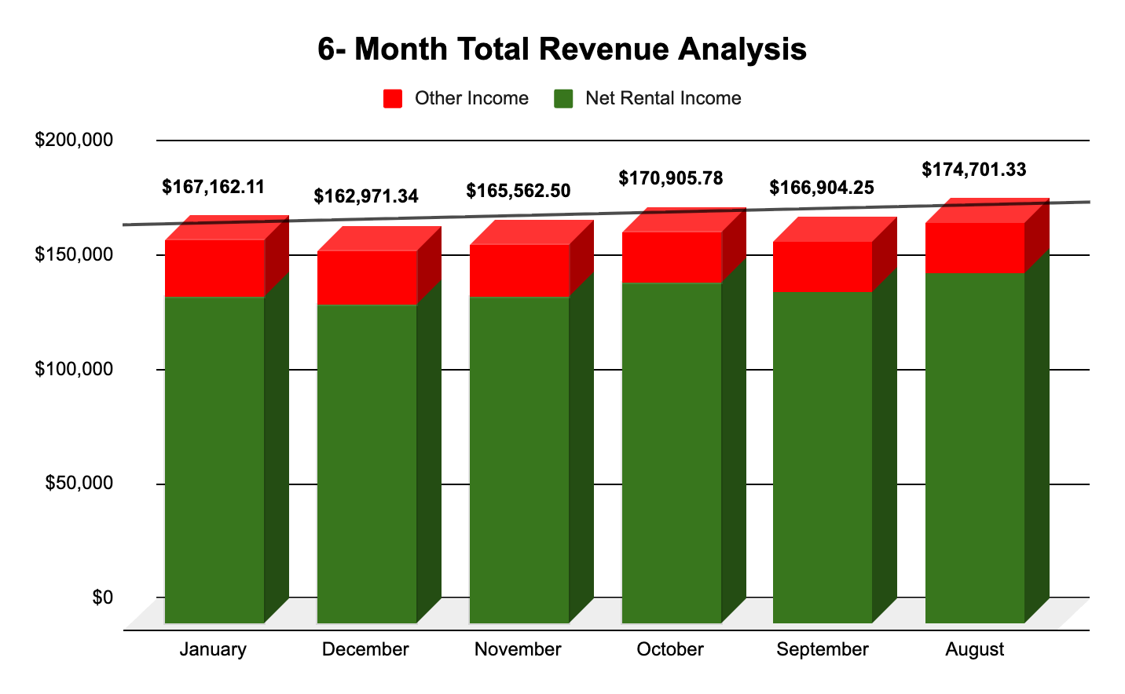

C.2 Financial Audit (Budget Vs. Actual)
- January outperformed budget overall: income was slightly under by $1.7K due to lower rental income, but strong expense control (down $9.2K) drove NOI $7.5K above budget. Lower non-operating expenses further improved results, reducing the net loss to $9.5K vs. the projected $27.8K. Action: prioritize increasing rental income, review insurance overages, and maintain tight expense control.

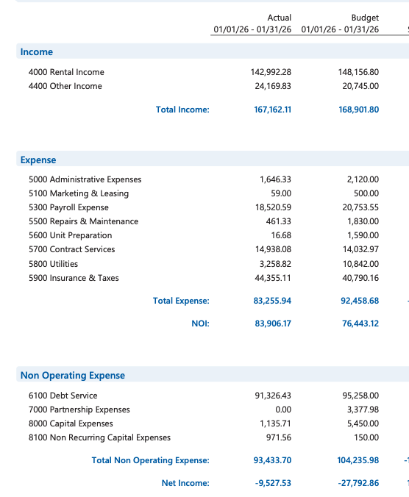
To-do list:
- Make sure that the property’s budget plan is updated for a clear outline of anticipated income and expenses.

APPENDIX 12

C.3 Collection Analysis
- Current Aged receivables and delinquency summary. Data extracted February 22 ,2026 as of January 31,2026.
- 12 units have more than 1k balance , all with notice.

APPENDIX 13:
Aged Receivables | January | December | November
0-30 | 18,002.96 | 11,042.16 | 12,948.82
31-60 | 265.60 | 1,550.47 | 10.05
61-90 | 2,471.47 | 0 | 0
Over 90 | 320.06 | 0 | 0
Total | 21,060.09 | 12,592.63 | 12,958.87

C.4 Expense Analysis
- Almost all expenses this month have shown an increase however it's still within our monthly average expense compared to the previous months except for the following expenses which shows drastic change

Account Name | January | December | November | October | September | August
Administrative Expenses | 1,646.33 | 1,078.06 | 1,543.54 | 1,241.79 | 2,175.13 | 2,108.26
Marketing & Leasing | 59 | 79.77 | 268.22 | 59 | 108.26 | 370.84
Payroll Expense | 18,520.59 | 19,670.00 | 19,887.64 | 20,293.03 | 19,913.53 | 19,989.72
Contract Services | 461.33 | 95 | 301.32 | 329.92 | 340.06 | 297.54
Repairs & Maintenance | 16.68 | 847.5 | 0 | 219.94 | 390.28 | 634.24
Unit Preparation | 14,938.08 | 14,059.26 | 16,132.16 | 14,569.05 | 15,977.13 | 11,618.10
Utilities | 3,258.82 | 13,082.05 | 12,383.19 | 13,142.58 | 11,426.37 | 11,282.99
Insurance & Taxes | 44,355.11 | -14,289.93 | 43,609.54 | 43,616.59 | 43,514.30 | 43,410.58
TOTAL EXPENSE | 83,255.94 | 34,621.71 | 94,125.61 | 93,471.90 | 93,845.06 | 89,712.27

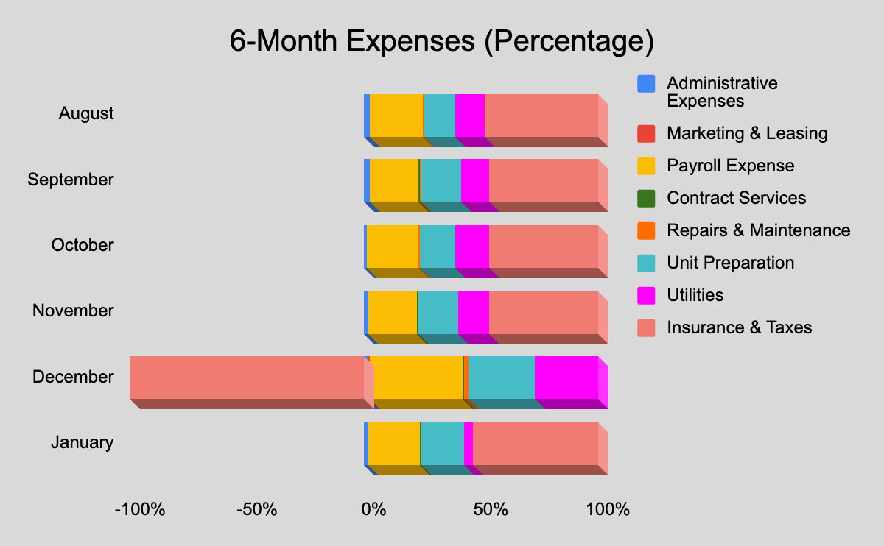

C.5 Rent Growth Analysis
- The property’s net rental growth has continued to increase by 2.48% for this month indicating a upward trend.
APPENDIX 15:
Rent Growth Analysis | January | December | November | October | September | August
Total Rental Income | 142,992.28 | 139,451.47 | 142,967.99 | 148,837.20 | 144,990.68 | 153,039.76
Growth Percentage | 2.48% | -2.52% | -4.11% | 2.58% | -5.55% | 8.53%

E. FINANCIAL ACCOUNT AUDIT REPORT:

E.1 Gross Potential Rent Analysis:

- Verandas has 160 units, with 137 occupied in november and 23 vacant.
- The total market rental for the property must be 174,390$, with a loss to lease to loss 2,615.10 $, implying that present market rents are nearly equal to effective rents, and the vacancy loss is 21,534.03 $, with 3,078 $ in concessions.
- In december the delinquency was $ 880.23

UNITS
160

OCCUPANCY | VACANCY | DOWN UNITS
137 | 23

MARKET RENT | LOSS TO LEASE | VACANCY LOSS | CONCESSIONS | ACTUAL RENT
174,390.00 | 2,615.10 | 21,534.03 | 3,078.00 | 139,451.47

MOVE IN | MOVE OUT
2 | 6

E.2 Concessions:

- Concessions are given for $ 6,796.25 in october 2025, with a loss to employee units of $ 340.50.

Unit no | Tenant | Description | Amount
401 | William Zarpate |  | 731.00
902 | Roger Meraz |  | 1,001.00
603 | Wilbert Caicedo Campaz | Cleaning apto 702 and touch fridge | 105.00
201 | Luis Pineda | Special $199 First month | 611.00
403 | Efren Rodriguez Arias | Cleaning Aptos 702-604-509-1104-1204- Office (6) | 630.00
 |  | Total | 3,078.00

E.3 MTM Analysis
- According to the general ledger, we are collecting $600 while the rent roll indicates $600
- We have to collect month to month from tenants whose lease expiration is overed
- These tenants lease expiration is not updated, if tenant lease agreement is overed charge month to month fees

E.4 Admin and Application Fees Analysis
- We have collected $198 as administrative fees,
- How much in administrative fees do we have to collect from new tenants?
- This month's application fees were collected $150
- We have to collect the application fee from new move in tenants
E.5 Utility Income Analysis
- The common area electricity charges were $234.88
- While the vacant unit electricity cost $1403.73 Why are we paying so much for unused space? And we are paying this much for empty units?
- We collected $7,456.04 from the tenants for water and sewer and paid 11,121.89 $
E.6 RUBS Analysis:
- According to the general ledger, parking income is $2,381.45however, the rent roll indicates that we must collect $2,255
- According to the general ledger, the washer and dryer generate $150 income, and the rent roll requires us to collect $185.
E. 7 Software Charges Analysis:
- In december we paid $150 as computer expenses.

E.8 Marketing Charges Analysis:
- Marketing and advertising charges for this month $ 79.77
- We spent on marketing and advertising, primarily through online sites like Google and Apartments.com

E.9 Payroll Analysis:

- Payroll must be defined because it changes from month to month.
- In december we paid a payroll of $ 19,670

5300 Payroll Expense | Amount
5310 Managers Salary | 3,880.00
5320 Leasing Agents Wages | 3,230.15
5330 Maintenance Supervisors Salary | 4,936.63
5335 Assistant Maintenance Wages | 3,774.20
5365 Bonuses | 1,275.00
5380 Insurance and Other Benefits | 1,268.72
5385 Payroll Taxes | 1,305.30
Total 5300 Payroll Expense | 19,670.00

E.10 Maintenance / Repairs Analysis:

- We spent $301.32 on maintenance and repairs in november
- HVAC, carpet cleaning, plumbing, and other services.
- Unit preparation charges not yet updated
E.11 Accounts Payable Aging Analysis:

- In november we paid total of $ 51,818.29 to vendors

E.12 3rd Party Contract Analysis

- For Contract Services we paid $ 16,132.16 in november with management fees included.

E.13 Late Charges / Penalties Analysis

- Tenants are being charged late fees totalling $3,601 which needs to be explained. How much does each tenant have to pay, and when is the last payment due?

E.14 Bank Statement vs. Accounts Differences

- Bank statements should be examined.

Prepared by: Checked by: Verified by:

____________________ _____________________ ___________________
Bernadette Berania Clyde De Jeus /Siva Amara Sridhar Sannidhi
Asset Manager Financial Controller/Auditor President & CEO
GW2R LLC GW2R LLC GW2R LLC

